**Text Classification Report**

**1. Classification Approach**

In this project, I fine-tuned a pre-trained large language model (LLM)—specifically, "MoritzLaurer/deberta-v3-large-zeroshot-v1", a zero-shot learning model—to adapt it to the given dataset (training.csv). The fine-tuning process involved training the model on labeled examples to improve its performance on the target classification task. This approach leverages the advantages of a pre-trained transformer-based model, enabling it to generalize well with limited training data while effectively capturing contextual relationships within the text.

**2. Preprocessing and Fine-Tuning Steps**

To ensure data quality and model efficiency, I implemented the following preprocessing and fine-tuning steps:

**Data Preprocessing**

* **Lowercasing:** Converted all text to lowercase to maintain uniformity and reduce variations in word representation.
* **Feature Engineering:** Combined the “title” and “abstract” into a single large column, “text” column, for simplicity and to provide more context for classification.
* **Handling unbalanced Class problem:** Oversampled all classes to match the largest category to mitigate the impact of unequal class distribution. (reference1)
* **Data Augmentation:** Applied synonym replacement and random word shuffling on half of the samples in each class to introduce variability.
* **Stratified Data Split:** Used an 80-20 stratified split to maintain equal class distribution in both training and validation sets. The final dataset consisted of 748 training samples and 188 validation samples.

**Fine-Tuning Process**

* **Epoch Selection:** Experimented with different epoch values to ensure the model was fully trained without overfitting.
* **Batch Size:** Due to computational constraints, a batch size of 2 was used for fine-tuning, which ensured stable training while optimizing available resources.
* **Gradient Accumulation:** Implemented **gradient accumulation with 4 steps** to simulate a larger batch size (**like we set batch size = 8**) for more stable gradient updates without increasing memory usage or avoiding OOM errors

**3. Conclusion**

In this project, I fine-tuned the **"MoritzLaurer/deberta-v3-large-zeroshot-v1"** model for text classification while implementing various **data preprocessing and fine-tuning techniques** to enhance performance.

To **mitigate class imbalance**, I applied **oversampling** and **data augmentation** techniques, ensuring a more balanced dataset. Additionally, I utilized **gradient accumulation** to simulate a larger batch size and prevent memory-related issues. Lastly, **Hyperparameter tuning** was conducted to find the optimal number of epochs and batch size while avoiding overfitting.

As a result of these efforts, the **final model achieved an accuracy of 0.913 on the validation dataset**.

**4. Future Improvements**

To further improve model performance in the future, I would explore the following strategies:

* **Data Enlargement & Augmentation:** Increase dataset size by fetching more labeled data or applying advanced data augmentation techniques, such as **back translation and sentence paraphrasing**, to improve generalization. Also, I might try different Boosted oversampling methods like **SMOTE or ADASYN** to address class imbalance.
* **Experimenting with Other LLMs:** Evaluate various **transformer-based models** (e.g., **BERT, RoBERTa, T5**) to compare classification performance and determine which one is the most effective architecture.
* **Alternative Machine Learning Methods:** Assess the feasibility of **traditional classifiers**, such as **Multi-label Logistic Regression, SVM, and Random Forest**, to see if simpler models can achieve comparable or better results with lower computational costs.
* **Boosted Resampling Techniques:** Implement **Bootstrap Aggregating method** to reduce variance and improve robustness. This method can also be used to compare performance across different models.
* **Ensemble Learning:** Explore **Stacking and Voting Classifiers** to combine predictions from multiple models, enhancing classification accuracy. (Like Boosted tree combines multiple small trees to get better prediction)
* **Hyperparameter Tuning:** Conduct research for how to reach the **optimal hyperparameters** (e.g., **learning rate, dropout rate, batch size**) to fine-tune model performance and prevent overfitting.

Reference 1

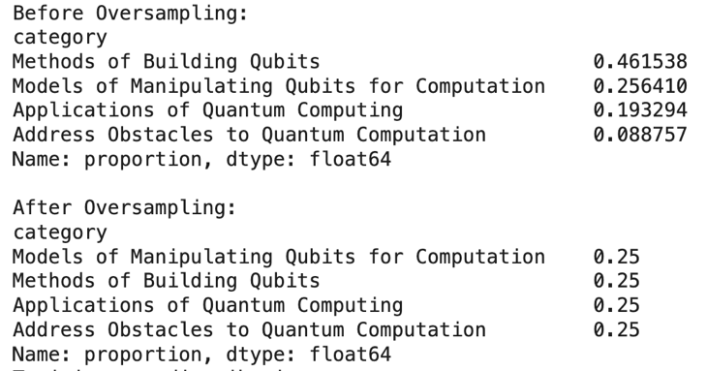

Code Reference:

<https://colab.research.google.com/drive/1q7nSMpsf218Ecsoh9FVN5CfPBVDFQ2rk>